Quantitative Module F

Simulation

**Background**

Simulation is often the default solution methodology for problems that are too complex to solve analytically. Simulation can mimic very complicated scenarios with many random variables. The actual system being modeled does not have to be physically built and tested, and computer simulation can compress time (run “years” of simulated time in just seconds or minutes). Sophisticated modeling takes a fair amount of training, but regular business managers can develop certain types of Monte Carlo simulations rather easily with Excel. Furthermore, with a little bit of training, managers can use one of the commercial simulation programs that use graphical aids so that the user can point and click the various machines and workers onto the screen. These icons usually have an associated parameter input box with pre-defined fields for inputting the most important attributes. The programs also automatically calculate many of the expected simulation output measures such as utilization rates, throughput amounts, etc. Simulation is very widely used in industry, and it helps all managers to have some idea of how it works and be on the lookout for good potential applications.

**Class Discussion Ideas**

1. To help motivate the topic, instructors can ask the students to help identify simulations that they know about from the real world. Example might include flight simulators for pilots, bombing missions for the military, econometric predictions, weather forecasting models, and disaster recovery practice for health care workers (using people pretending to be injured). Even basketball practice where a substitute on the team tries to play like an upcoming opposing player is a type of simulation.

**Active Classroom Learning Exercises**

1. *Let’s Make a Deal Simulation*

The old game show *Let’s Make a Deal* had a contest with an optimal strategy that has proven to be less than obvious among many people. As described in “Which Door Has the Cadillac,” *Decision Line*, Dec.-Jan., 1999, pp. 17-19, the game itself is relatively simple. A great prize is located behind one of three curtains, and the other two curtains hide some sort of joke prize. The player chooses the curtain that he or she thinks has the big prize. The master of ceremonies (MC) then opens one of the other two curtains (this one never has the big prize). The MC then gives the player the choice of *staying* with the original curtain or *switching*. The optimal strategy is always to *switch* (2/3 probability of winning), but many people think that they should *stay* (1/3 probability of winning).

Most students do not seem to have heard what the optimal strategy for this game is. It can be a fun way to introduce simulation by using cups to play the game with the class and recording the answers. (Hand out candy or some small prize to each student that guesses correctly.) Record each play with the columns: “1st Cup,” “Revealed Cup,” “Final Cup,” “Prize Cup,” and “Prize (Y/N)?” Generate a set of random integers between 1 and 3 inclusive (in Excel this is *=RANDBETWEEN(1,3)*) for the number of students that will be playing the game, and place the prize in the cup indicated by your random draws. Interestingly, many more students use the *stay* strategy than one might guess. Also, they will commonly look at the results up to their turn and base their strategy on the trends that they see on the screen.

If enough players participate, the results usually support the theory. Of course an important issue to point out afterwards is that the length of the simulation run was not long enough to feel very comfortable with the conclusions. At this point instructors can mention how a computer simulation can run this same simulation for thousands of trials in an instant. In fact, Excel can handle this problem rather easily with the help of some *IF* statements. The instructor could bring an Excel program to class to show the evidence or even have the students produce one as an assignment. (Each trial of the simulation should be played by both *stay* and *switch* strategies.) For several hundred trials the computer gives very close to the answer that we would expect: *stay* wins about 1/3 of the time, and *switch* wins about 2/3 of the time. (The exposed curtain/cup is always known by the MC to be a non-winner, so that information is actually useless to the player. Odds suggest that the player had a 2/3 probability of being wrong to begin with, so *switching* makes it a 2/3 probability of being right.)

**Presentation Slides**

INTRODUCTION (F-1 through F-4)

Slide 4: This is a screen shot from a computer simulation program called Micro Saint. This application was used by the Bay Medical Center to address overcrowding. By simulating different numbers of doctors and staff, simulating the use of another clinic for overflow, and simulating a redesign of the existing clinic, Bay Medical Center was able to make decisions based on an understanding of both costs and benefits.

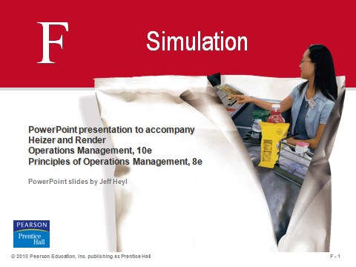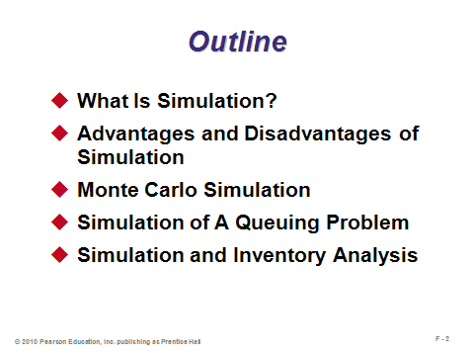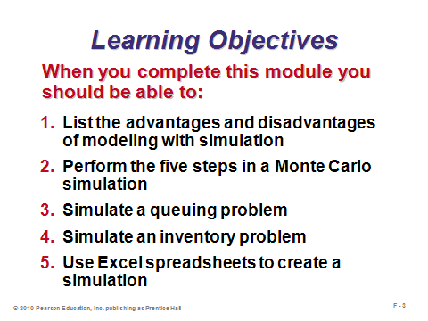

**F-1 F-2 F-3**

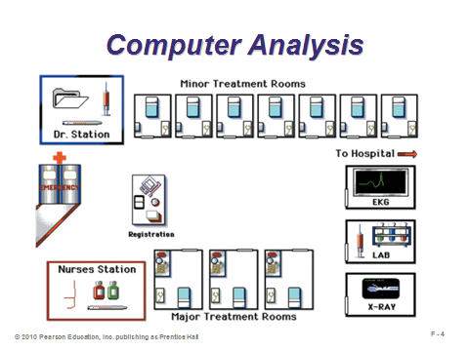

**F-4**

WHAT IS SIMULATION? (F-5 through F-8)

Slides 5-6: Slide 5 describes what simulation is. Slide 6 (Table F.1) identifies several of the many possible applications of simulation.

Slides 7-8: Slide 7 describes the steps of simulation, and Slide 8 (Figure F.1) illustrates them.

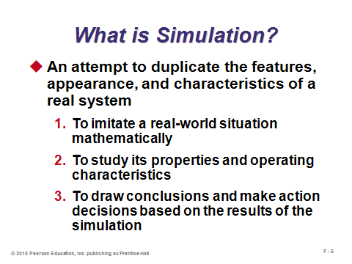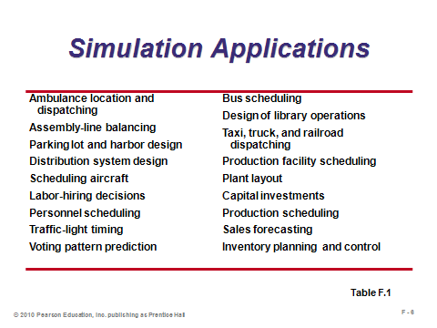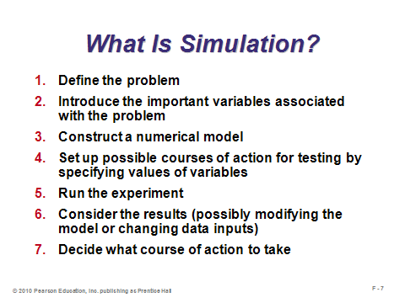

**F-5 F-6 F-7**

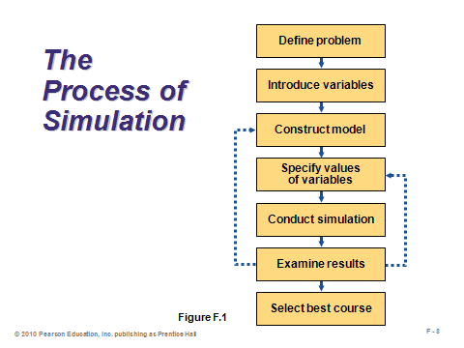

**F-8**

ADVANTAGES AND DISADVANTAGES OF SIMULATION (F-9 through F-11)

Slides 9-11: Slides 9 and 10 identify several advantages of simulation. In general, once a problem becomes complex enough, simulation emerges as the tool of choice. Slide11 identifies several disadvantages. Simulation does not guarantee optimal solutions as do linear programming and many other techniques presented in the text. The effectiveness of the final solutions is dependent in large part upon the modeler’s experimental design skills.

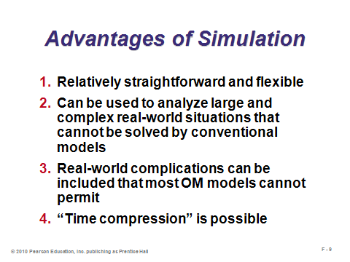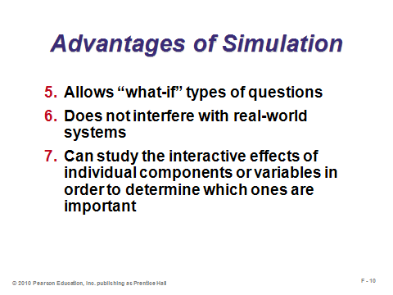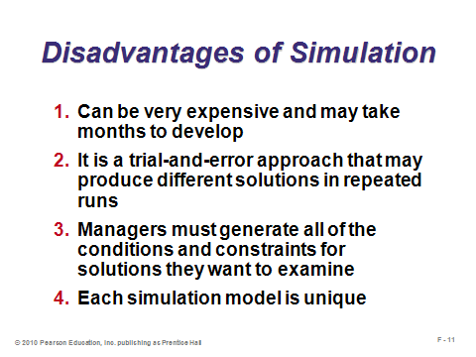

**F-9 F-10 F-11**

MONTE CARLO SIMULATION (F-12 through F-17)

Slide 12: Uncertainty arises due to random variation, lack of knowledge, or error. Computer simulation uses computer models to imitate real life or to make predictions. *Monte Carlo* *simulation* not only identifies what could happen, but how likely it is to happen. Monte Carlo simulation is basically a sampling experiment whose purpose is to estimate the distribution of an outcome variable that depends upon several probabilistic input variables. Slide 12 identifies the five steps in Monte Carlo simulation.

Slides 13-17: These slides follow an example through all five simulation steps. Slide 13 (Table F.2) presents the probability distribution information for tire demand at Barry’s Auto Tire. Slide 14 (Table F.3) assigns random number intervals to each possible realization of demand. (Author Comment from the text: “You may start random number intervals at either 01 or 00, but the text starts at 01 so that the top of each range is the cumulative probability.”) Slide 15 (Table F.4) presents a set of random (technically pseudo-random) numbers. The simulation itself is performed in Slides 16 and 17 (Example F1). Notice how the average realized demand through 10 days of simulation was almost one full unit higher than the expected demand based on the probability distribution. As the number of days simulated grows, that gap would generally shrink.

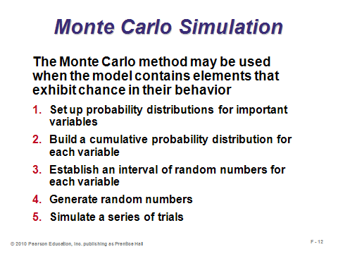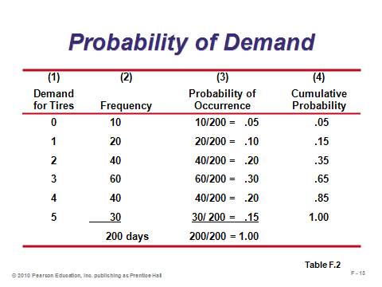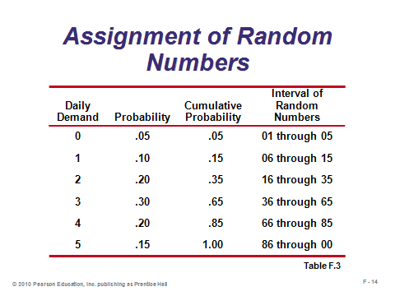

**F-12 F-13 F-14**

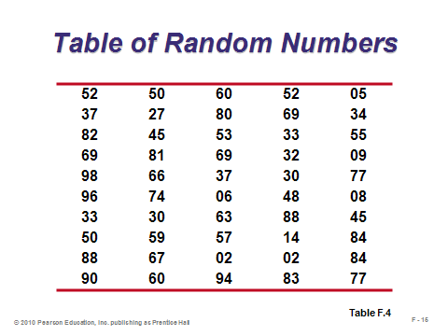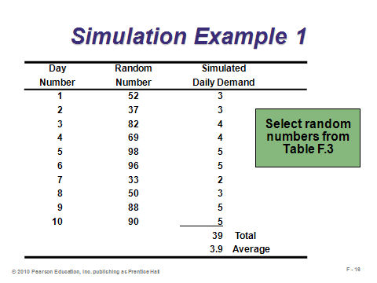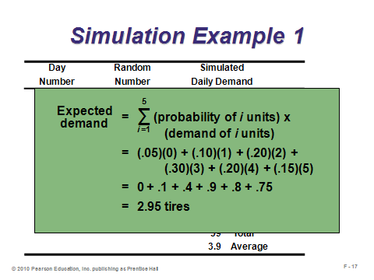

**F-15 F-16 F-17**

SIMULATION OF A QUEUING PROBLEM (F-18 through F-21)

Slides 18-21: These slides present a queuing system (Module D) example (Example F2), where the arrivals are not Poisson-distributed and the service times are neither exponential nor constant. Thus, analytical modeling would be difficult, so we turn to simulation. Slide 18 presents the probability and random interval information for arrivals, while Slide 19 presents that information for barge unloading rates (the service component of the problem). Slide 20 presents the simulation over 15 days. In this application, the daily results build on each other, that is, column 2 is positive if the service rate from the previous day was not high enough to unload all waiting barges. Slide 21 presents important output measures that can be computed with the simulation data. Measures like this help management make decisions about the future.

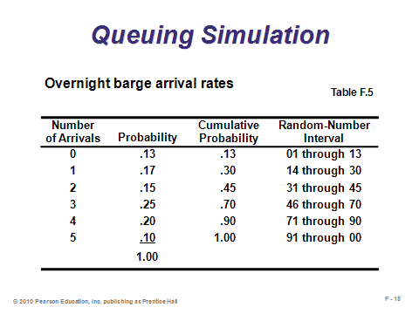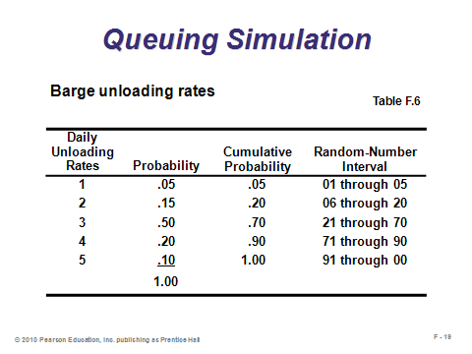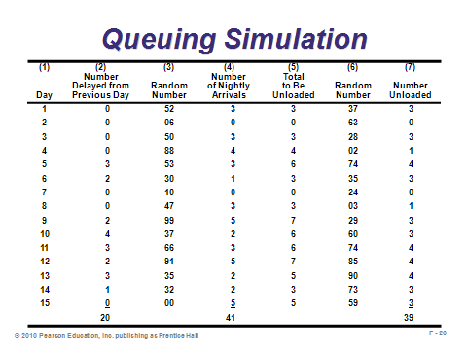

**F-18 F-19 F-20**

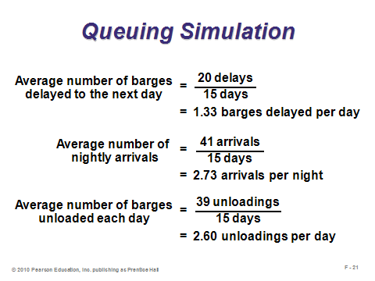

**F-21**

SIMULATION AND INVENTORY ANALYSIS (F-22 through F-27)

Slides 22-27: These slides present an inventory system (Chapter 12) example (Example F3), where the demand and lead times are described by special distribution functions. Thus, analytical modeling would be difficult, so we turn to simulation. Slide 22 presents the probability and random interval information for demand, while Slide 23 presents that information for lead time. The owner has decided to test an inventory policy with a reorder point of 5 units and an order quantity of 10 units. Slide 24 presents the steps for this specific inventory simulation, and Slide 25 shows the results of simulating 10 days. Note that for this application if the lead time is one day, the order will not arrive the next morning but rather at the beginning of the following workday. (This is why Day 9, Column 2 has an order received of 10 units, even though the order was placed on Day 6 and the realized lead time was 2 days.) Slide 26 presents output measures from the simulation, and Slide 27 computes relevant costs. This simulation was only 10 days long for illustration purposes. In reality, the owner should run it for many more days, say 1000, to draw meaningful conclusions. Then other simulations should be run to test competing inventory policies. (Note that in simulation analysis, we often use *common random numbers* when comparing policies. In this way, differing results should be based on different policies rather than on differences in chance outcomes.)

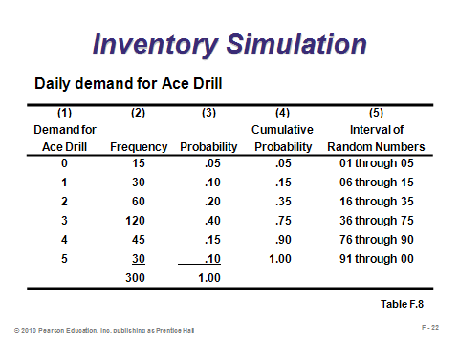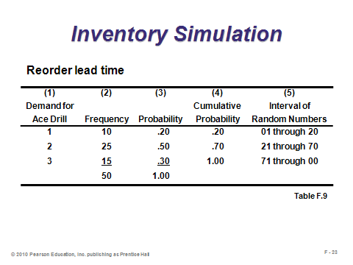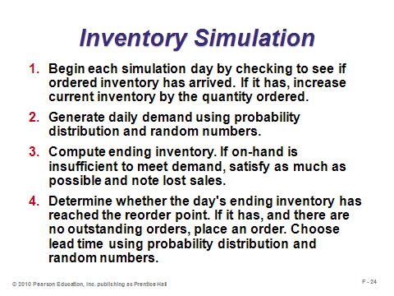

**F-22 F-23 F-24**

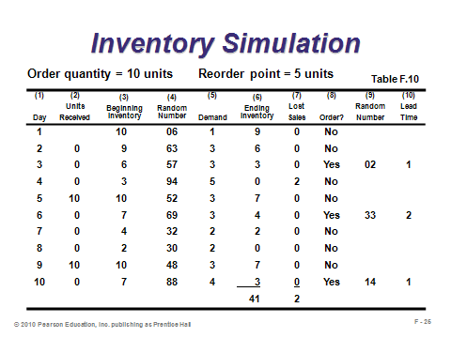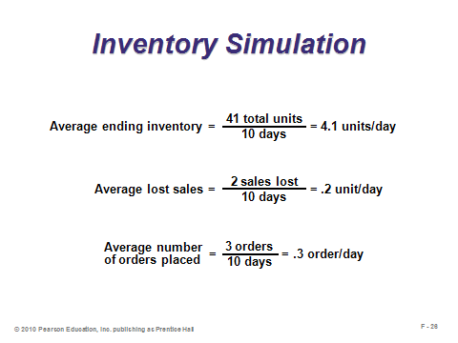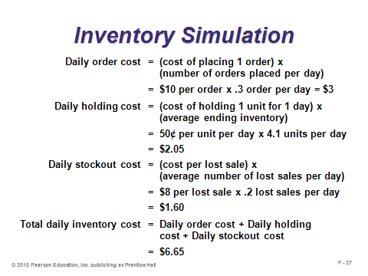

**F-25 F-26 F-27**

USING SOFTWARE IN SIMULATION (F-28 through F-30)

Slides 28-29: The examples in this module used tables of random numbers to generate simulations by hand, but computers are almost always used in practice. Essentially any type of general purpose code can be used, but usually modelers try to write their simulations in general-purpose simulation packages, commercial software programs, or spreadsheets. Excel add-ins such as Crystal Ball and @Risk are also popular.

Slide 30: This slide (Program F.1) shows how the Barry’s Tire Shop example might be implemented in Excel.

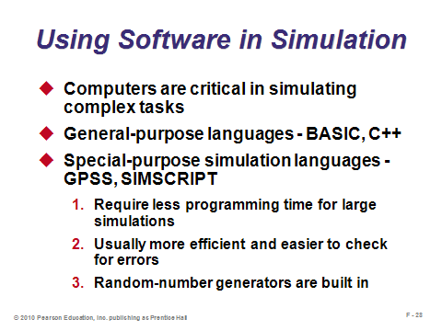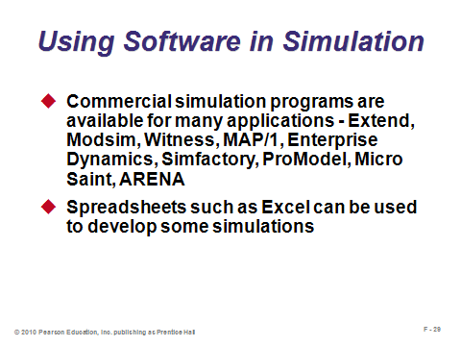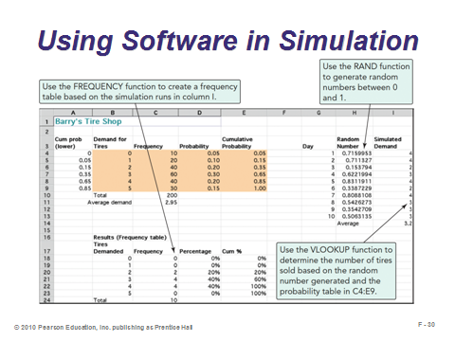

**F-28 F-29 F-30**

**Additional Assignment Ideas**

1. Visit the Web sites of any simulation software product and describe its features. Some possible starting places are:

* + Extend from Imagine That: http://www.imaginethatinc.com/
  + Micro Saint from Micro Analysis & Design: http://www.maad.com/

**Additional Case Studies**

Internet Case Study (www.pearsonhighered.com/heizer)

* *Saigon Transport*: This Vietnamese shipping company is trying to determine the ideal truck fleet size.

Richard Ivey School of Business (http://cases.ivey.uwo.ca/cases/pages/home.aspx)

* *Red Cross Mobile Blood Clinics-Improving Donor Service* (#9B00D024): A regional director of donor services for the American Red Cross was wondering how to improve services to blood donors. Faced with an increasing number of complaints that donors were being held up in long lines at Red Cross' mobile blood collection operations—commonly termed bloodmobiles—she was considering several design alternatives for the blood collection process.

**Other Supplementary Material**

Videos

Films available from:

Society of Manufacturing Engineers

One SME Drive

P.O. Box 930

Dearborn, Michigan 48121-0930

(P) 313-425-3000

(F) 313-425-3412

http://www.sme.org

* *Simulation—*Rohr Corporation, Intel Corporation, and General Electric simulate to plan better. Order # PI-VT253-3456
* *Virtual Manufacturing: Simulating Reality—*Explore potential of the interactive human/computer environment as it changes the faces of manufacturing to make complex data easier to understand. Order # PI-VT517-3456